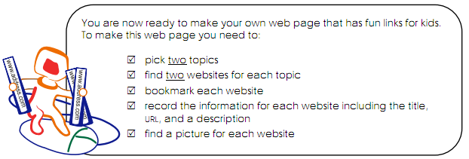
Country 1: _________________
Website Title 1:
Website address: http://
Website description (1-2 sentences):
Picture: don’t forget to save a picture! When you find one, hold ctrl and click it, select save image as, and choose either your usb or personal folder.

Website Title 2:
Website address: http://
Website description (1-2 sentences):

Picture: don’t forget to save a picture! When you find one, hold ctrl and click it, select save image as, and choose either your usb or personal folder.

Country 2: _________________
Website Title 1:
Website address: http://
Website description (1-2 sentences):

Picture: don’t forget to save a picture! When you find one, hold ctrl and click it, select save image as, and choose either your usb or personal folder.

Website Title 2:
Website address: http://
Website description (1-2 sentences):

Picture: don’t forget to save a picture! When you find one, hold ctrl and click it, select save image as, and choose either your usb or personal folder.

Finally, think of a cool name for your website. Remember the internet safety stuff we discussed way back in term one…
__________________________________________________________________

