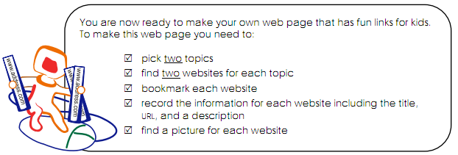
Topic 1: _________________

Topic 2: ____________________

Finally, think of a cool name for your website. Remember the internet safety stuff we discussed way back in term one…

__________________________________________________________________

