Answer these three questions:
1. What do the initials WWW represent? ______________________________________
2. What is the Internet or "Net"? ____________________________________________ ______________________________________________________________________
3. What is the difference between the two? _____________________________________ ______________________________________________________________________
5. Name two different search engines. __________ __________
6. Name two different web browsers. __________ __________
Write definitions for the following internet terms:
- URL ________________________________________________________
- Address Bar __________________________________________________
- Hyperlink _____________________________________________________
- 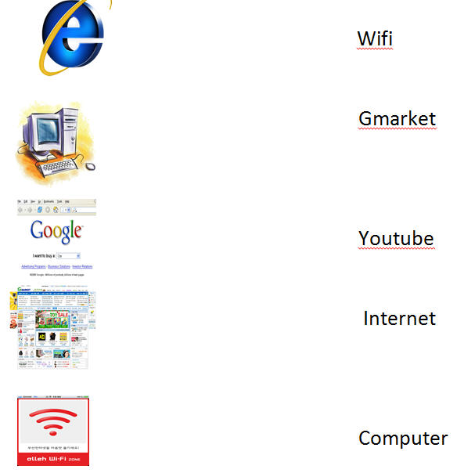
Here’s a hint:
- Type “define” followed by the term you want defined. For example, define internet…
- Write your response in the space provided.

